End User Survey Analysis

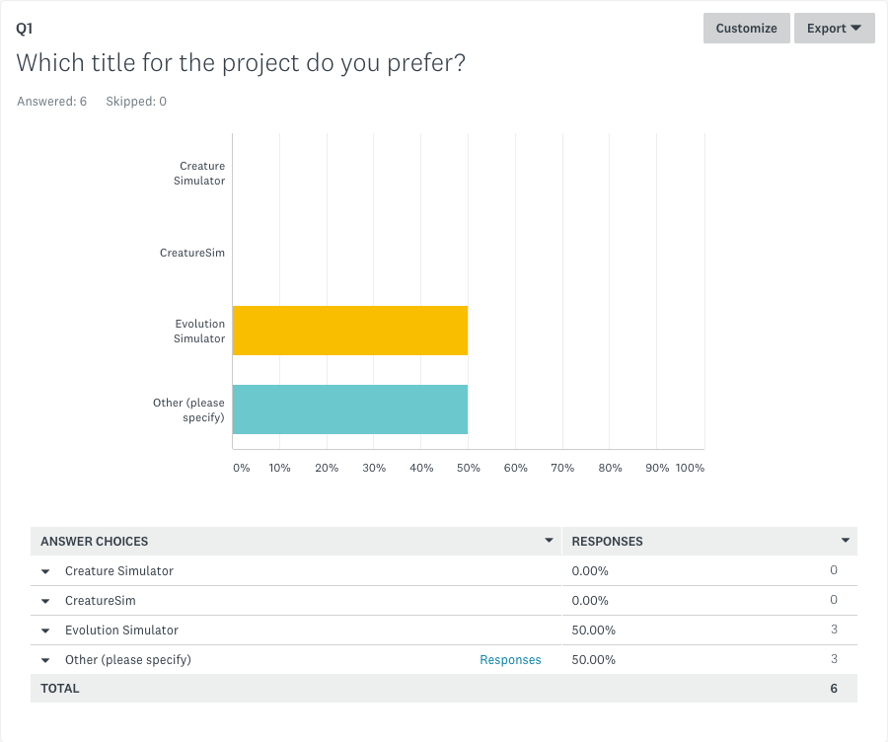

The majority of end-users seemed to prefer the name Evolution Simulator as a title for my project, so that was going to be the name for my project. However, after conducting the survey I discovered Evolution Simulator was already the name of another product, so to avoid issues regarding the Copyrights Designs and Patents Act I will call my program CreatureSim instead

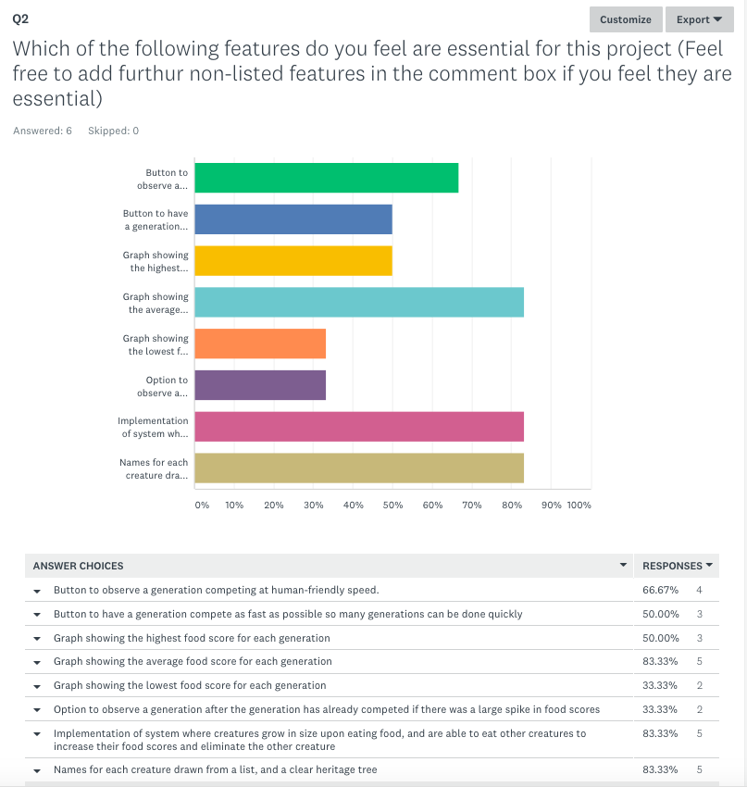

Before creating the survey I would have decided the following were core features that needed to be implemented and could not be left unimplemented if time was an issue:

* Button to observe a generation competing at human-friendly speed.
* Button to have a generation compete as fast as possible so many generations can be done quickly

However due to popularity in end-user responses, I have decided to label the following as core features to be focused on after the above two:

* Graph showing the average survival time for each generation
* Implementation of system where creatures grow in size upon eating food, and are able to eat other creatures to increase their food scores and eliminate the other creature
* Names for each creature drawn from a list.

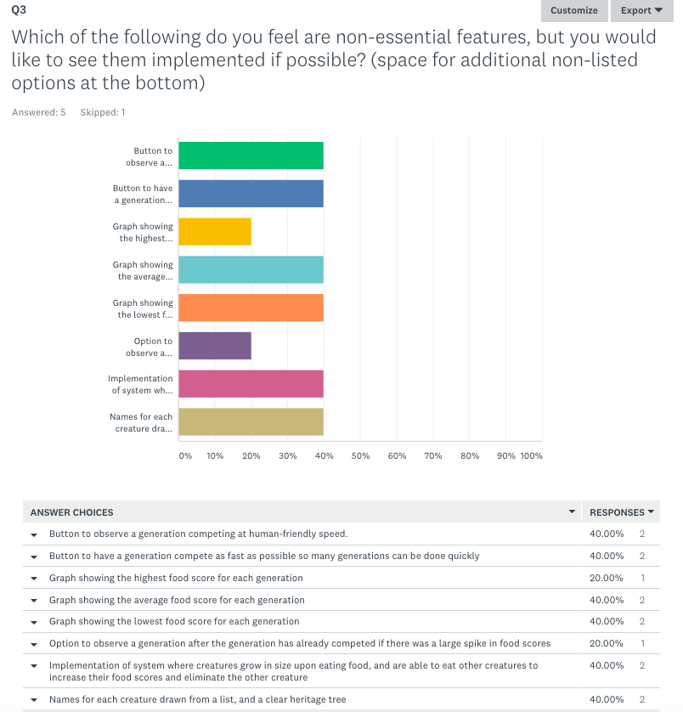

Due to unpopular demand, I will leave the following features until the end, if time allows:

* Graph showing the highest survival time for each generation
* Graph showing the lowest survival time for each generation
* Option to observe a generation after the generation has already competed if there was a large spike in food scores

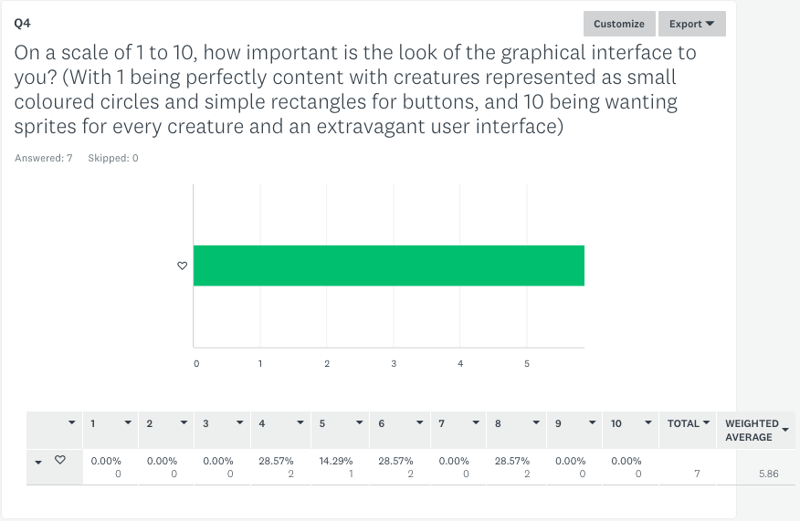

The average end-user seems to care a fair amount about the looks of the GUI, so at the end of development I will spend some time creating sprites and backgrounds and buttons. However I will not do this until the rest of the program has been implemented